Gonzales, Hendwrick Mitchel A.

Project : Jumpee

**Jumpee Demo**

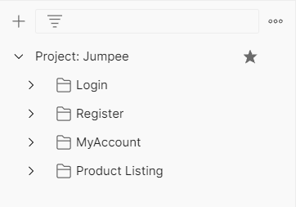

**#1: You cannot access my account page features if you are not registered user.**

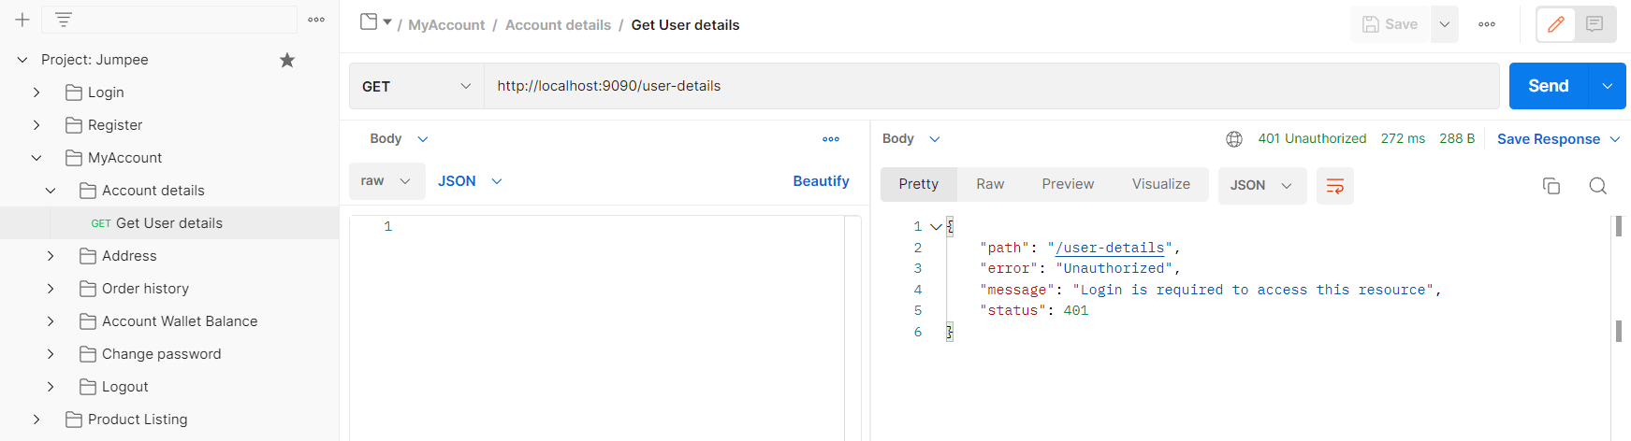

**#1.1: There will be unauthorized error and message once you try to access my account features without signing in.**

**#2: Under product listing page add-to-cart, checkout, get user cart will redirect you to login page, so that you can login first to access those features.**

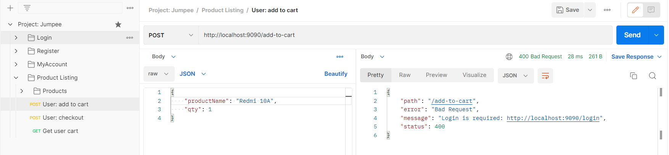

**#3: Now, let’s register a user.**

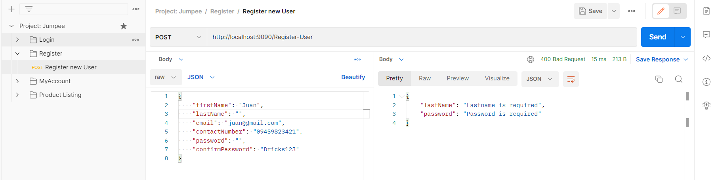

**#3.1: You need to meet all the requirements in registration; message will appear if you didn’t meet the requirements on the specific field.**

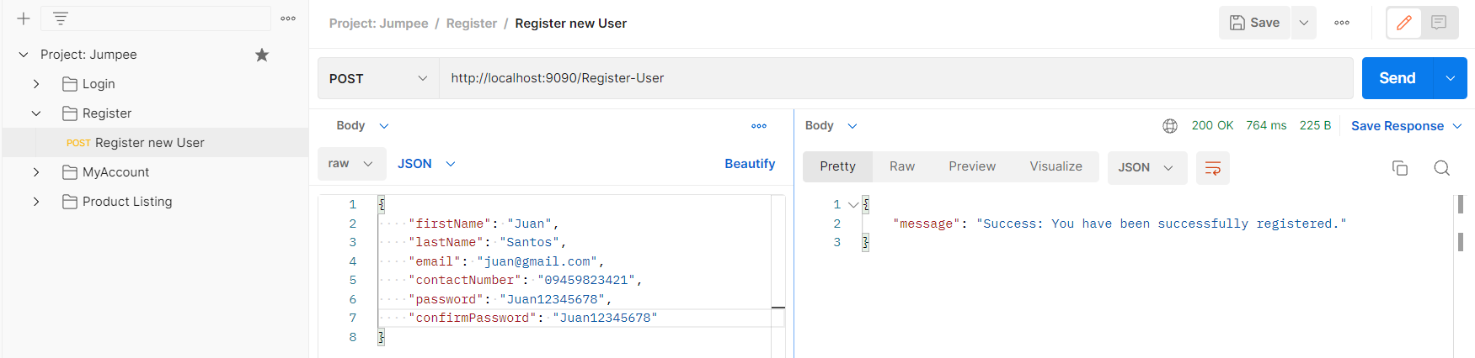

**#3.2: You are now registered, now let us login.**

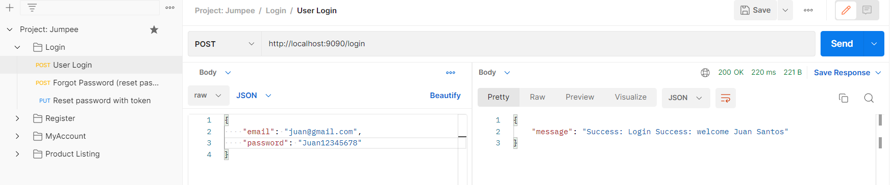

**#4: Now let’s try all the features in my account page.**

**#4.1: Address: add, update, show, and delete are now working.**

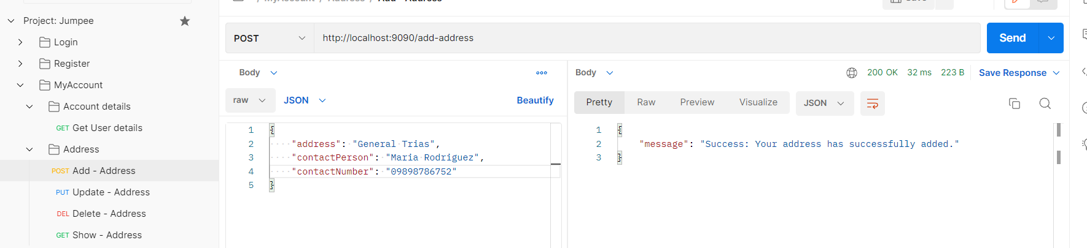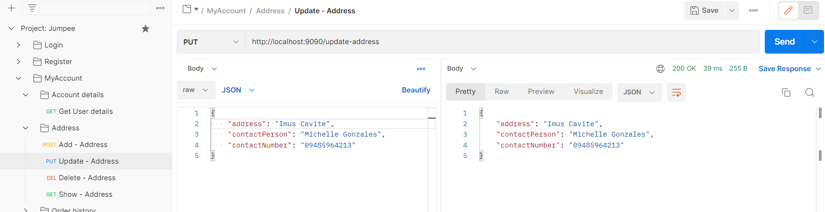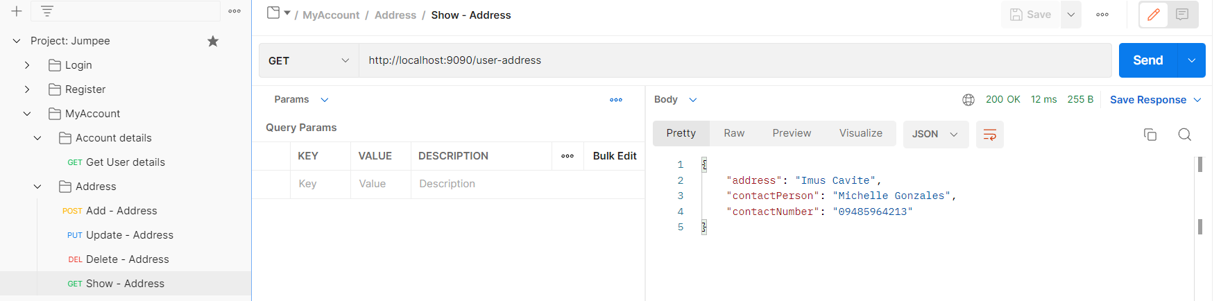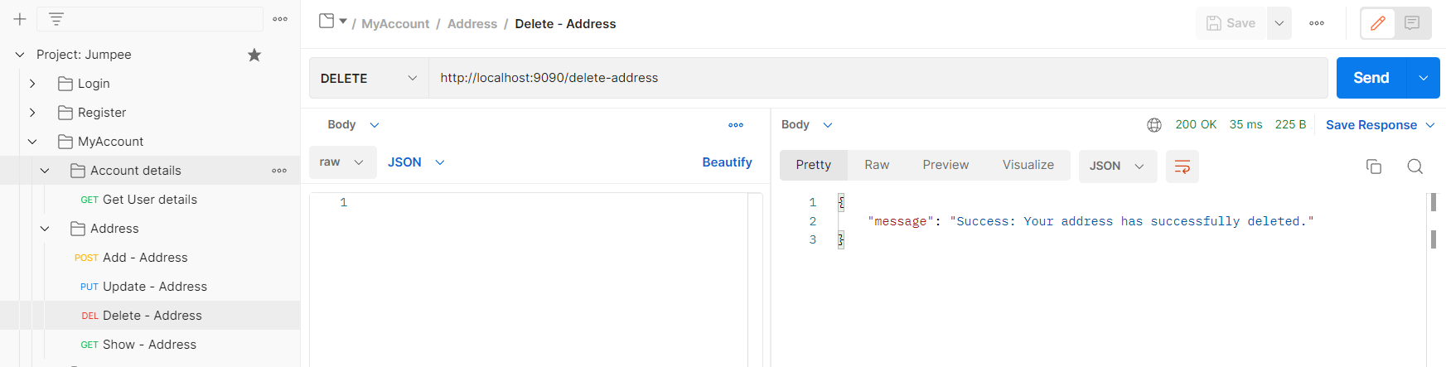

**#5: Let us now activate our account wallet by adding any amount of money and deposit, check wallet balance and check wallet history.**

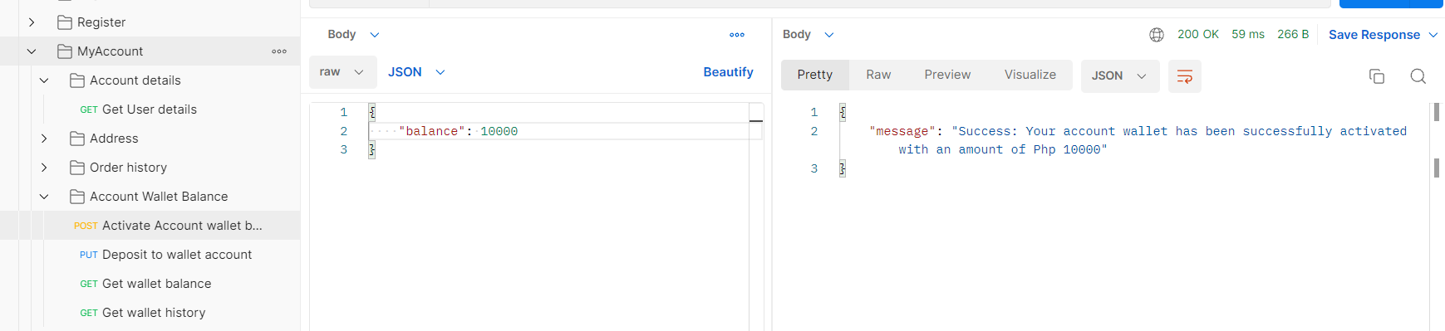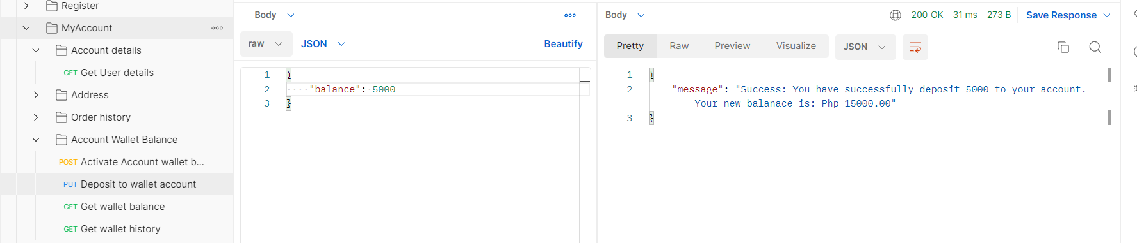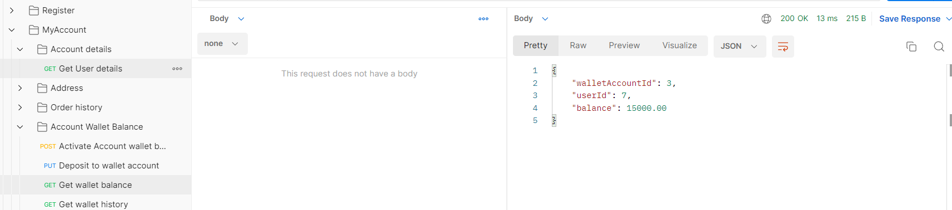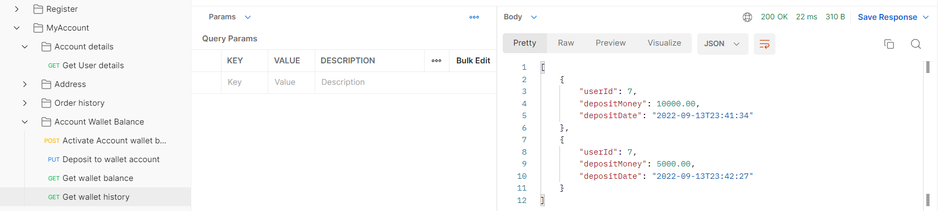

**#6: Now let’s try change password under my account page.**

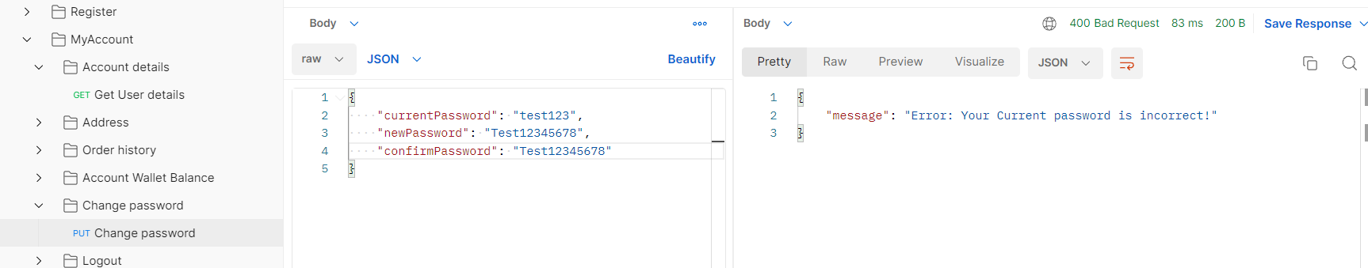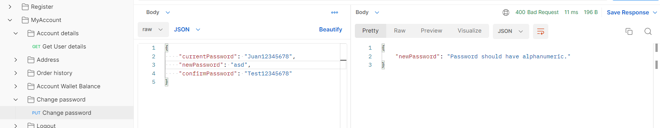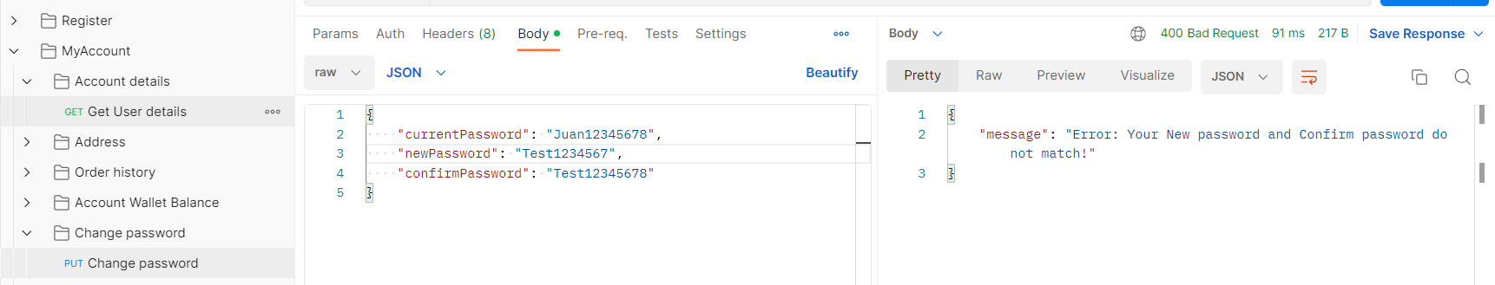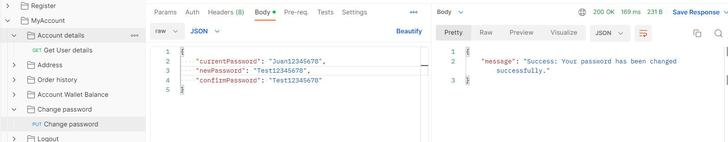

**#6.1: Make sure your current password is correct and new password and confirm password is equal or match.**

**#7: Now let’s try product listing page**

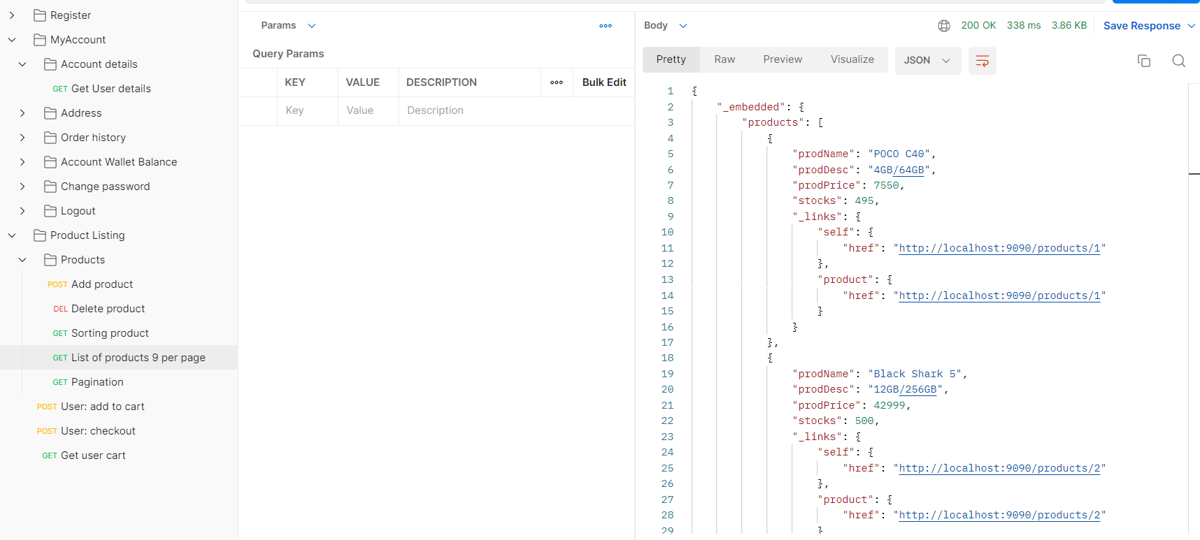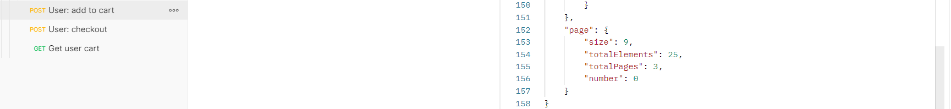

**#7.1: List of products 9 product per page. Add, delete, sorting, pagination are all working.**

**#7.2: Now let’s add to cart and checkout.**

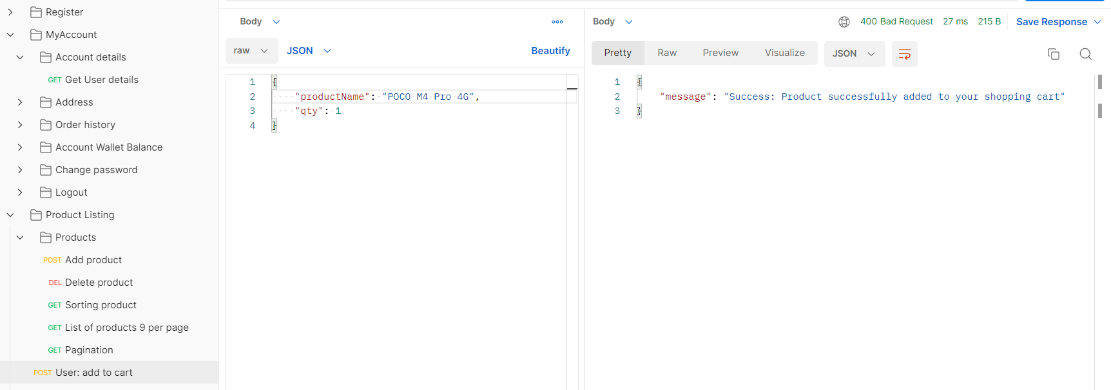

**#7.3: Check user cart, copy order number and paste it to checkout to complete the transaction.**

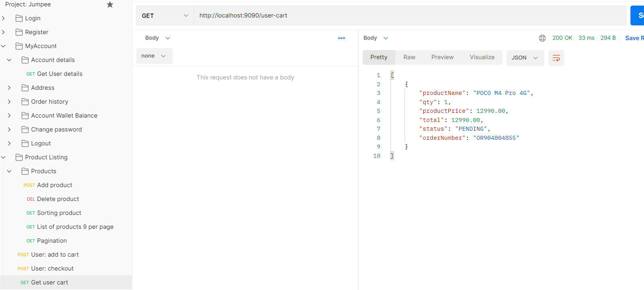

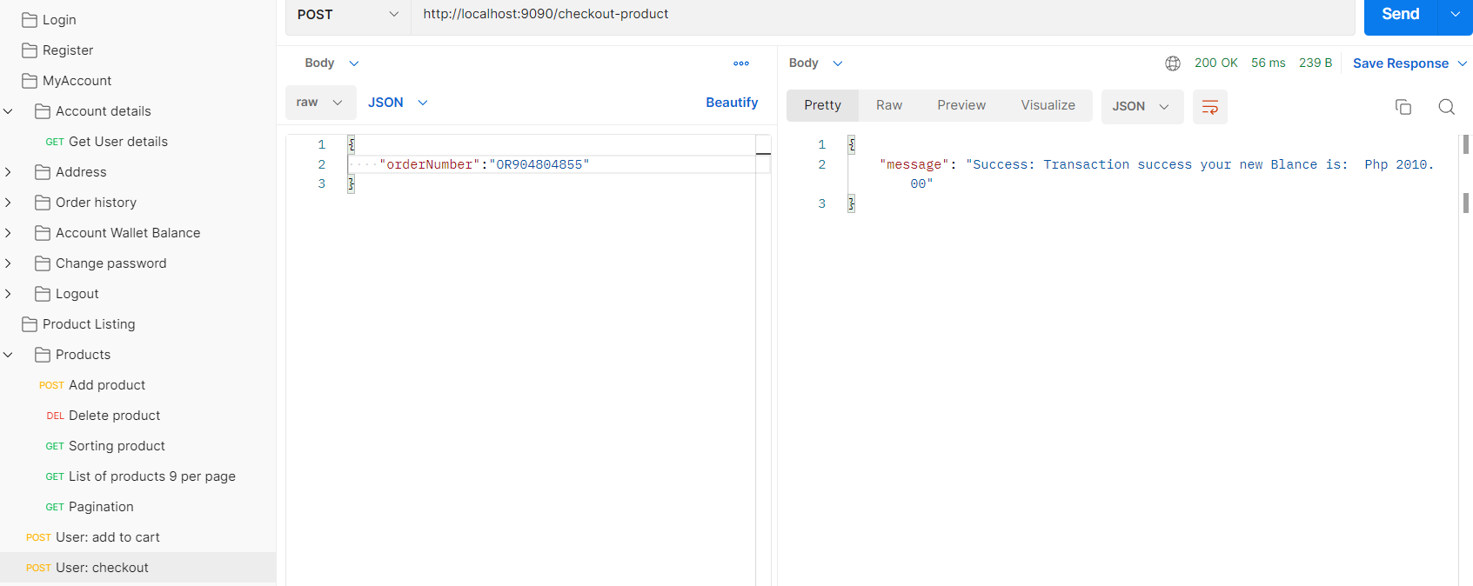

**#7.4: It successfully checkout the product.**

**#8: Let’s try forgot password under login page. You need to provide your email and you will receive a token and you need to copy it.**

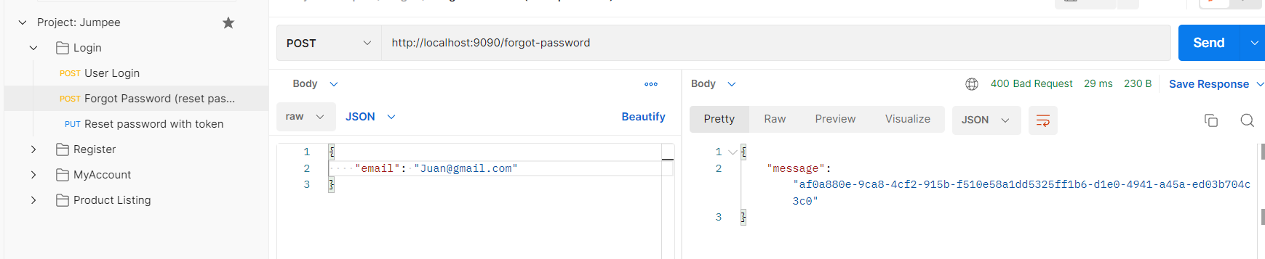

**#8.1: Make sure your token is correct or it will display Invalid token.**

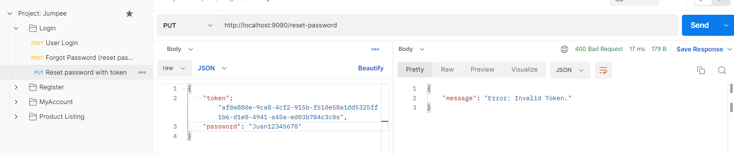

**#8.2: Once your token is correct and you provide your new password correctly**

**message success will appear. Now you can try your new password.**

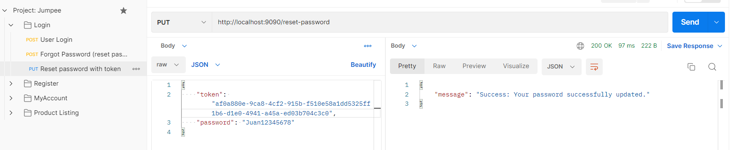

**END.**